**EAST WEST UNIVERSITY**

**CSE438**

**Section: 01**

**Lab: 02 Report**

**Topic: Contrast stretching,** **bit plane slicing,** **using Logarithmic Transformation and Power-law Transformation.**

**Submitted By:**

**Name: Md Sifat Ullah Sheikh ID: 2022-1-60-029**

**Submitted To:**

**K.M. Safin Kamal**

**Lecturer**

**Department of Computer Science & Engineering**

**Date: 7 July 2025**

**Q1. Use contrast stretching on the image from Figure 1.**

**CODE:**

import cv2

import numpy as np

import matplotlib.pyplot as plt

fig_01_path = '/kaggle/input/lab-02/Lab_02/Picture1.png'

fig_01 = cv2.imread(fig_01_path,cv2.IMREAD_GRAYSCALE)

def show_image(fig_01_path, title = "", cmap='gray'):

plt.imshow(fig_01_path, cmap = cmap)

plt.title (title)

plt.axis ('off')

plt.show

show_image(fig_01,"Figure_01")

import os

output_dir = '/kaggle/working/img'

output_path = os.path.join(output_dir, 'comparison_contrast_stretching.png')

os.makedirs(output_dir, exist_ok=True)

def contrast_stretching(fig_01):

min_val = np.min(fig_01)

max_val = np.max(fig_01)

stretched = ((fig_01 - min_val) / (max_val - min_val)) * 255

return stretched.astype(np.uint8)

stretched_image = contrast_stretching(fig_01)

fig, axs = plt.subplots(1, 2, figsize=(10, 5), dpi=300)

axs[0].imshow(fig_01, cmap='gray')

axs[0].set_title('Original Image')

axs[0].axis('off')

axs[1].imshow(stretched_image, cmap='gray')

axs[1].set_title('Contrast Stretched')

axs[1].axis('off')

plt.tight_layout()

plt.savefig(output_path, dpi=300, bbox_inches='tight', pad_inches=0)

plt.show()

plt.close()

print(f"Comparison image saved successfully to: {output_path}")

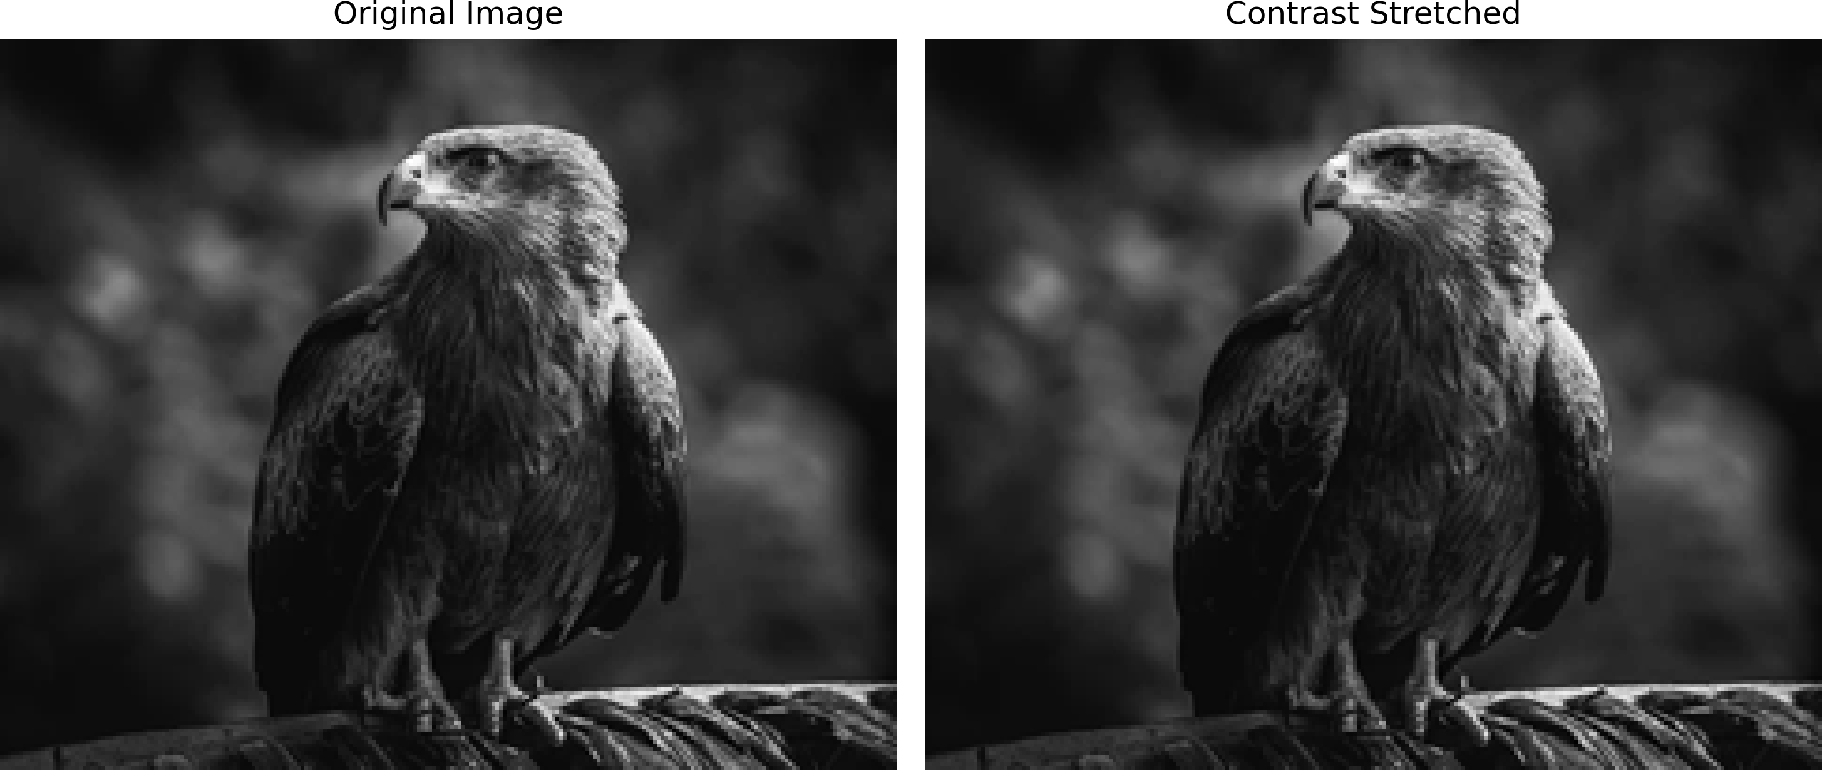

output_dir = '/kaggle/working/img'

output_path = os.path.join(output_dir, 'histogram_contrast_stretching.png')

def show_image_and_hist(img, title):

fig, axs = plt.subplots(1, 2, figsize=(10, 4))

# Display image

axs[0].imshow(img, cmap='gray')

axs[0].set_title(title)

axs[0].axis('off')

# Display histogram

axs[1].hist(img.ravel(), bins=256, range=(0, 256), color='blue')

axs[1].set_title('Histogram')

plt.tight_layout()

plt.savefig(output_path, dpi=300, bbox_inches='tight', pad_inches=0)

plt.show()

stretched_img = contrast_stretching(fig_01)

show_image_and_hist(fig_01,"Orginal Figure_01")

show_image_and_hist(stretched_img,"Contrast Stretched Figure_01")

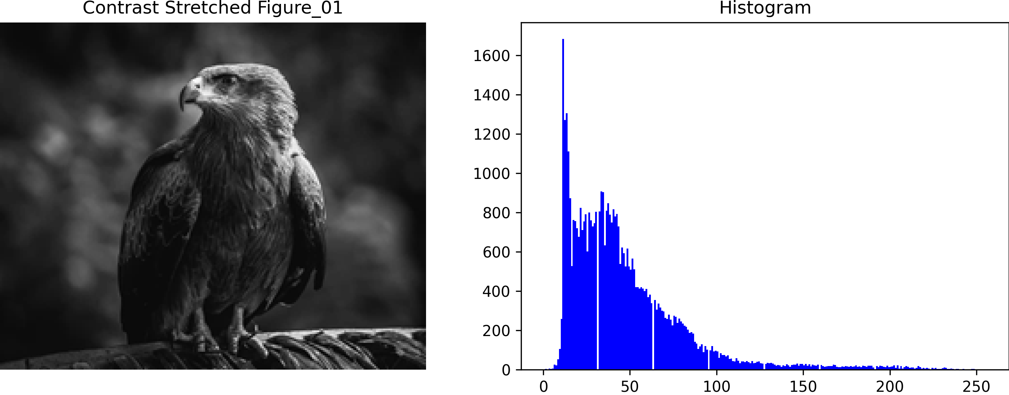

**Q2. Apply bit plane slicing on the image 1**

**CODE**

output_dir = '/kaggle/working/img'

output_path = os.path.join(output_dir, 'bit plane slicing on the image.png')

# Extract bit planes

bit_planes = []

for i in range(8):

bit_plane = (fig_01 >> i) & 1

bit_planes.append(bit_plane * 255)

fig, axs = plt.subplots(2, 4, figsize=(12, 6), dpi=300)

fig.suptitle('Bit Plane Slicing', fontsize=16)

for i in range(8):

row = i // 4

col = i % 4

axs[row, col].imshow(bit_planes[i], cmap='gray')

axs[row, col].set_title(f'Bit Plane {i}')

axs[row, col].axis('off')

plt.tight_layout(rect=[0, 0, 1, 1])

plt.savefig(output_path, dpi=300, bbox_inches='tight', pad_inches=0)

plt.show()

plt.close()

print(f"Bit plane slicing image saved to: {output_path}")

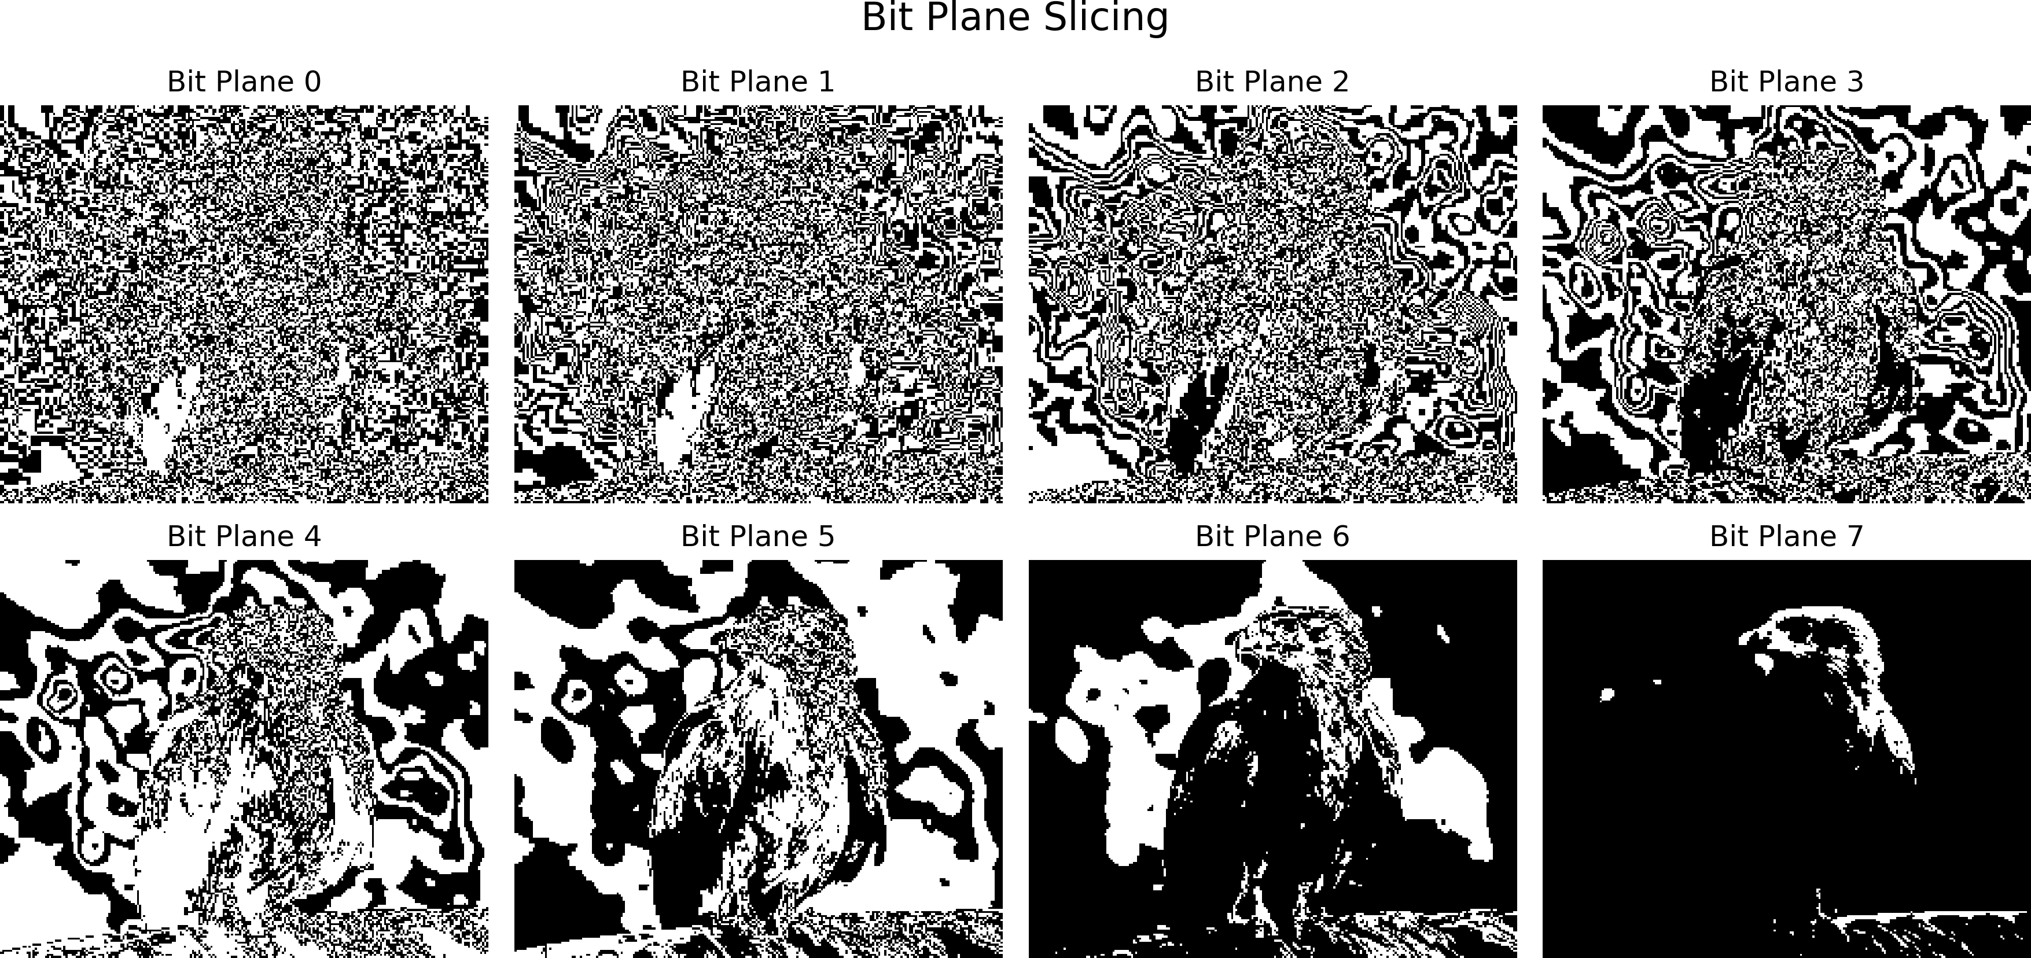

**Q3. Change the contrast of the image using Logarithmic Transformation and Power-law Transformation.**

**CODE**

def log_transform(img):

img_float = img.astype(np.float32)

c = 255 / np.log(1 + np.max(img_float))

log_image = c * np.log(1 + img_float)

return np.uint8(np.clip(log_image, 0, 255))

def gamma_transform(img, gamma=0.5):

img_normalized = img / 255.0

gamma_corrected = np.power(img_normalized, gamma)

return np.uint8(np.clip(gamma_corrected * 255, 0, 255))

log_img = log_transform(fig_02)

gamma_img = gamma_transform(fig_02, gamma=0.5)

titles = ['Original Image', 'Log Transform', 'Gamma Transform (γ=0.5)']

images = [fig_02, log_img, gamma_img]

plt.figure(figsize=(15, 5), dpi=300)

for i in range(3):

plt.subplot(1, 3, i+1)

plt.imshow(images[i], cmap='gray')

plt.title(titles[i])

plt.axis('off')

plt.tight_layout()

output_dir = '/kaggle/working/img'

os.makedirs(output_dir, exist_ok=True)

output_path = os.path.join(output_dir, 'figure02_log_gamma_transform.png')

plt.savefig(output_path, dpi=300, bbox_inches='tight', pad_inches=0)

plt.show()

print(f"Transformed image saved to: {output_path}")

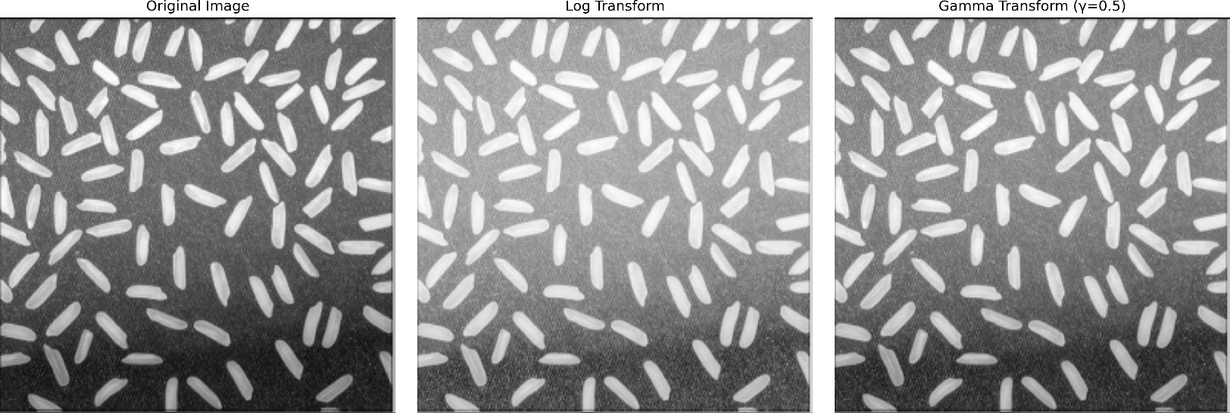

fig, axs = plt.subplots(3, 2, figsize=(12, 12), dpi=300)

fig.suptitle('Image and Histogram Comparison', fontsize=16)

for i in range(3):

axs[i, 0].imshow(images[i], cmap='blue')

axs[i, 0].set_title(titles[i])

axs[i, 0].axis('off')

axs[i, 1].hist(images[i].ravel(), bins=256, range=(0, 256), color='gray')

axs[i, 1].set_title(f'Histogram of {titles[i]}')

axs[i, 1].set_xlim([0, 255])

plt.tight_layout(rect=[0, 0, 1, 0.96])

output_dir = '/kaggle/working/img'

os.makedirs(output_dir, exist_ok=True)

output_path = os.path.join(output_dir, 'figure02_log_gamma_hist_comparison.png')

plt.savefig(output_path, dpi=300, bbox_inches='tight', pad_inches=0)

plt.show()

print(f"Image and histogram comparison saved to: {output_path}")

